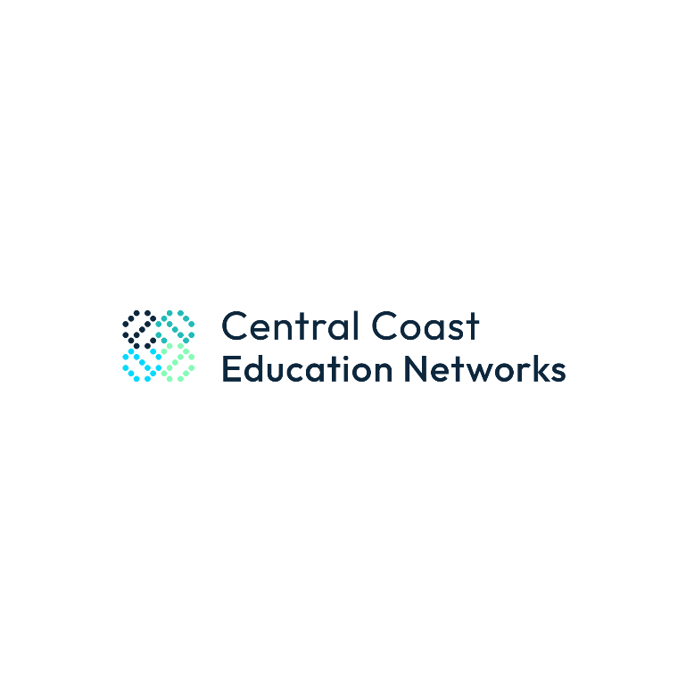
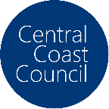
Central Coast Council
Industry into Schools Project

Preparing For A Career on the Coast

Lesson Plan

Clarity of Learning Objective
By the end of this lesson, students will understand the role of local government in economic development, the importance of businesses to local economies, and potential career opportunities in their region.

Lesson Sequence / Instructional Strategies

Note: Have students complete the associated student worksheet as they progress through this lesson

Lesson 1 – Our Coast (Foundations)

Step 1: Evaluation of Prior Knowledge (5 minutes)
- Introduction/Classroom Discussion
To gauge students' existing knowledge, the teacher will begin with a brief discussion centred on the following questions:
- What do you think when we say "local government"?
- What do you think we mean when we say “economy”?
- What do you think we mean when we say “local economy”?
- What do you think we mean when we say “industry”?
- How do you think local governments may be able to influence the economy of a community?
- Can anyone share examples of local businesses or industries in our area?

Step 2: Video Presentation & Discussion (25 minutes)
A short video featuring Andrew Powrie, Economic Development Manager of Central Coast Council, discussing the role of local government, the Central Coast economy, and the businesses and jobs that are here now and into the future.
As set out in the student worksheet, the teacher will inform the students that they should take notes on:
- Key economic strengths of the Central Coast
- Emerging industries discussed
- Challenges faced by the local economy
- Career opportunities mentioned
Video: Empowering Local Economies: Insights from Andrew Powrie (link: https://vimeo.com/1090811432)

Step 4: Classroom Discussion
After the Andrew Powrie video, the teacher will lead a guided discussion, asking students:
- What key strengths did Andrew mention about the Central Coast's economy?
- What challenges were the big challenges for the Central Coast economy growing into the future?
- Which emerging industries stood out to you, and why do you think they are important?

Step 5: Video Presentation & Discussion 15 minutes
In this conversation, Mitch McCormack, Head of Executive and Technical Recruitment at Rarekind, discusses the current state of recruitment, the importance of soft skills, and the community-oriented environment of the Central Coast. He highlights the challenges and opportunities in the job market, emphasising the need for a holistic view of candidates that includes both technical and soft skills.
The teacher will inform the students that they should take notes on:
- Recruitment challenges and opportunities.
- In-demand careers and talent shortages.
- Importance of soft skills and community involvement.
- Critical communication skills.
- Sense of community and support for local businesses.
- Emerging industries and their impact.
- Importance of networking and ways to build a network.
Video: Preparing for a Career on Our Coast: Mitch McCormack, Rarekind (link: https://vimeo.com/1090795219)

Step 6: Classroom Discussion
After the interview, lead a guided discussion using the questions provided. Encourage students to share their notes and insights, fostering a collaborative learning environment.
- In-Demand Careers:
  - What are some careers that are in demand on the Central Coast?
  - Why is there a talent shortage in certain careers?
- Skills and Attributes:
  - What is the importance of soft skills according to Mitch?
  - How do employers view hobbies and community involvement in the recruitment process?
- Community and Local Business:
  - What is unique about the sense of community on the Central Coast?
  - How do local businesses benefit from community support?
- Networking:
  - Why is building a network important according to Mitch?
  - What are some ways to build a network in the Central Coast?

Step 7. Reflection and Credential
If the second lesson, ‘the extension’ is not going to be completed, have students complete the Central Coast Education Networks online reflection log, to be awarded the ‘Central Coast Education Networks – Career Aware 2025, digital credential.
Note: Digital Credentials are not awarded to a student until a parent consent form, electronically or other, has been provided to Central Coast Education Networks: Form can be downloaded here or completed online here:

Lesson 2 – Extension: Interactive Group Activity (sprint)

Step 1: Interactive Group Activity (50 minute)
Students will be divided into small groups and assigned one of the following topics relating to Central Coast to explore and then present a short presentation back to the class:
The role of:
- Tourism in Central Coast economy
- Central Coasts Food Innovation Industry
- Central Coast Health Sector
- Leading Technology Companies
- Central Coast Council
Each group will:
- Research their topic using the internet
- Prepare a short presentation (2-4 minutes) on their findings.
- Consider, outline potential careers in their assigned topic.

Step 2: Class Presentations (15 minutes)
Groups will present their findings to the class. Peers will be encouraged to ask questions and discuss each presentation, fostering critical thinking.

Step 3: Reflection and Credential
Have students complete the Central Coast Education Networks online reflection log, to be awarded the ‘Central Coast Education Networks – Career Ready 2025, digital credential

Adaptation for More/Less Confident Pupils
- More Confident Pupils: These students can be encouraged to delve deeper into the economic theories related to local government and propose innovative solutions to existing challenges. They could also assist in peer teaching during group activities.
- Less Confident Pupils: Provide structured templates for group presentations, including key points they must cover, and allow them to contribute to larger chunks of the group’s work rather than expecting solo presentations. Pair these students with supportive peers.

Assessment Strategies
Formative assessment will take place throughout the lesson:
- Participatory Assessment: Observing student engagement during discussions and group work.
- Presentation Feedback: Peer and teacher feedback on group presentations to assess understanding and communication skills.
- Exit Ticket: At the end of the lesson, students will submit a brief reflection (3-5 sentences) on what they learned about local government economic development and potential career pathways.

Incorporation of Technology
- Video Presentation Tools: Utilising digital platforms such as YouTube or a learning management system (LMS) for video delivery.
- Research Tablets/Laptops: Students will use devices to conduct research during the group activity, fostering digital literacy.
- Presentation Software: Students could use platforms like Google Slides or PowerPoint to create their presentations, cultivating their tech skills.

Resources Needed
- Video Interview: Andrew Powrie and Mitch McCormack
- Internet Research: tablets/laptops
- Projector and screen for video presentation
- Presentation materials (paper, markers etc.)

Key Vocabulary
- Economic Development: Activities that seek to improve the economic well-being and quality of life for a community.
- Emerging Industries: New sectors or segments in the economy that are developing rapidly.

Disciplinary and Substantive Knowledge Students Should Know
- The structure and functions of local government.
- The connection between local government decisions and economic outcomes.
- Understanding the challenges and opportunities of local economies, particularly in the context of the Central Coast region.

