Central Coast Council

Industry into Schools Project

### Lesson Overview

### Preparing for a Career on the Coast

### Lesson Theme: Connecting with Our Coast

**Lesson Sequence Overview**

The Central Coast Education Networks Preparing For a Career on the Coast lesson package is designed to help students understand the role of local government in economic development, the importance of businesses to local economies, and potential career opportunities in their region. It includes classroom discussions, video presentations, guided discussions, interactive group activities, and reflection exercises.

**Sustainable Development Goal Alignment**

* **SDG 8: Decent Work and Economic Growth** - This goal focuses on promoting sustained, inclusive, and sustainable economic growth, full and productive employment, and decent work for all. Understanding the role of local government in economic development and the importance of businesses to local economies directly aligns with this goal.
* **SDG 9: Industry, Innovation, and Infrastructure** - This goal emphasises building resilient infrastructure, promoting inclusive and sustainable industrialisation, and fostering innovation. The lesson guide's focus on economic development and career opportunities can contribute to achieving this goal.
* **SDG 11: Sustainable Cities and Communities** - This goal aims to make cities and human settlements inclusive, safe, resilient, and sustainable. By understanding the role of local government and businesses in local economies, students can contribute to creating sustainable communities.

**Key Features of Lesson Sequence**

* **Interdisciplinary Approach**

The lesson package combines Commerce, Geography, and Career Education to give students a comprehensive understanding of their region's industries, economy, social structure, and potential career opportunities.

* **Real-World Impact**

Students participate in activities that provide them with insights into their local economy and encourage reflection on potential career decisions and opportunities to explore while still in school.

* **Industry & Local Government Engagement**

The lesson package incorporates information from Central Coast Council and Rarekind, a recruitment and HR company located on the Central Coast. Students acquire knowledge about their local economy and the career opportunities, both current and emerging, from organisations at the forefront of developing the economic landscape and placing individuals in industries and jobs.

* **Central Coast Education Network's Credential**

Students who successfully complete the lesson and demonstrate their understanding of the local economy and careers in it will be awarded the Central Coast Education Network's Credential – Career Aware or Career Ready. This credential recognises their achievement and skills, providing them with a valuable addition to their academic and professional portfolio.

**Generalised Alignment Opportunities: Stage 4 & Stage 5 Commerce and Geography**

* **Stage 4 & Stage 5 C**ommerce: exploring/analysing individual rights and responsibilities, economic concepts, and the role of government and law,
* **Stage 4 & Stage 5** Geography: understanding diverse places and environments, how people interact with them, and different management and protection approaches.

**Student Digital Credentials**

Students completing the lesson sequence are invited to apply for a Central Coast Education Networks Digital Credential.

*In Central Coast Education Networks, we recognise and celebrate the learning and contributions of all, from student achievements and teacher development to industry and partner participation.*

*When we credential and badge these achievements, we’re also capturing valuable data insights and reflections, enhancing our understanding of stakeholders and enabling us to be genuine collaborators and supporters of their journeys in our Central Coast Education*

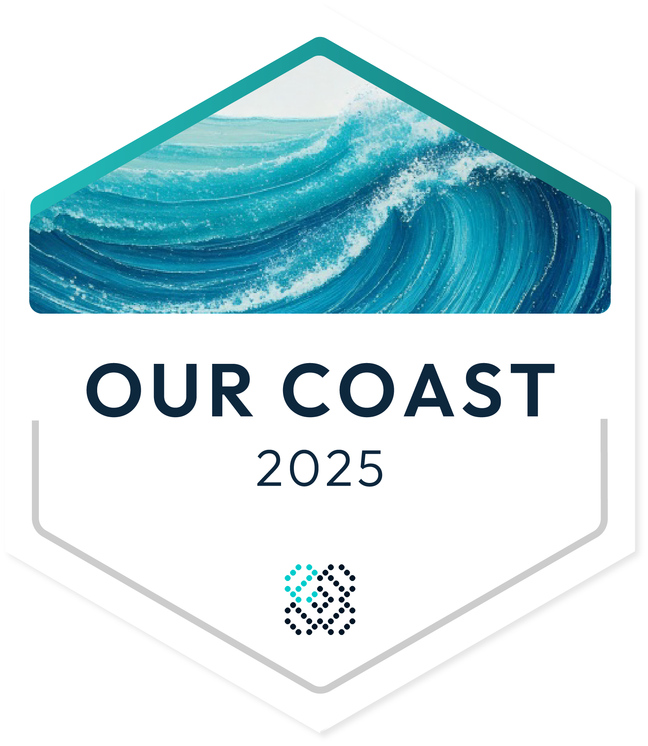Your students, should they choose, will be applying for the Central Coast Education Networks Credential: ‘Our Coast- Career Aware (Foundation) or ‘Our Coast-Career Ready’. To complete this application, students will be directed to a short online questionnaire.

Note: As students' names and emails are collected during the application process, parental or carer consent is required for students under sixteen (16) for the credential to be issued. Parents/Carers can complete this consent here: <https://centralcoast.educationnetworks.com.au/credentials-digital-badges/parent-carer-information>

**Contacts**

Questions regarding this learning sequence and Central Coast Education Networks can be directed to Duncan Burck, Project Lead:

e: [Duncan@mcbbp.com.au](mailto:Duncan@mcbbp.com.au)

m: 0448 654 007

<https://centralcoast.educationnetworks.com.au>