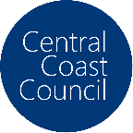

Central Coast Council

Industry into Schools Project

## Central Coast Education Networks 2025

## Digital Credential – Parent/Carer Permission Request

***Central Coast Education Networks is A Central Coast Council Economic Development Initiative***

*This Central Coast Council Pilot Project is an economic development strategic initiative designed to foster collaboration between education, industry, government, and the broader community. The project aims to create and enhance school programs & lessons that inspire young people to connect with commerce on the Central Coast and all its opportunities. The project’s central hub has been named****Central Coast Education Networks.***

**We request permission from parents and carers to issue an industry-recognised Digital Credential to students who complete Central Coast Education Network's curated classroom learning experiences and business engagement programs.**

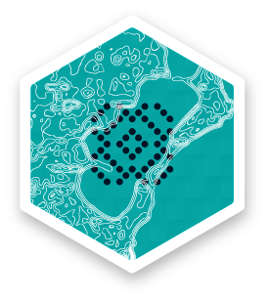The Central Coast Education Networks Digital Badges represent a modern and dynamic approach to recognising and validating students' skills and achievements while also gaining valuable, reflective insights from students relating to their experiences during the delivery of classroom programs*. The student's insights are being collected to inform the development and investment in further education programs by industry and government, supporting teachers in delivering learning experiences that will help prepare our young people for their future careers*.

This Permission Form informs you, as the parent or carer, about the Central Coast Education Network's Digital Credentials and requests permission for your child to apply for them, which includes providing their name and email address, upon successfully completing a learning experience.

Please be assured that students whose parents or carers choose not to provide permission for the issuance of Central Coast Education Networks Digital Credentials will not be disadvantaged. Instead, they will receive a hard copy certificate acknowledging their participation in the learning experience or business engagement program.

If you have any questions or require further clarification, please visit the Central Coast Education Networks website – <https://centralcoast.educationnetworks.com.au> or [contact us](https://centralcoast.educationnetworks.com.au/contact-us/) directly.

Central Coast Council

Industry into Schools Project

## Parent / Carer Consent – Central Coast Education Networks

**Online Version:** [**https://centralcoast.educationnetworks.com.au/credentials-digital-badges/parent-carer-information**](https://centralcoast.educationnetworks.com.au/credentials-digital-badges/parent-carer-information)

* I give permission for my child to receive Central Coast Education Networks Credentials and Digital Badges.
* I understand that my child will be required to provide Central Coast Education Networks with their name and email address so that the Digital Badge can be issued to them.
* I acknowledge that my child's information will be handled in accordance with Education Networks' [Privacy Policy](https://centralcoast.educationnetworks.com.au/privacy-policy/) and [Terms and Conditions of Use.](https://centralcoast.educationnetworks.com.au/cyber-city-terms-conditions-of-use/)
* I understand that my child's information will only be used to award the Central Coast Education Networks Credential & Digital Badge and will not be shared with anyone else without my and my child's consent.
* I understand that participation in the Central Coast Education Networks Credentialling and Digital Badging is voluntary, and we may withdraw at any time.

|  |  |
| --- | --- |
| Student Name: |  |
| Student School: |  |
|  | |
| If under the age of 18 – Please have a parent/carer/guardian authorise: | |
| Name: |  |
| Signature: |  |
|  |  |
| Email address:  Optional |  |

Please return the Student Permission Form – to your school coordinator or send to: admin@educationnetworks.com.au