Net Z(ed): Critical Thinking & Complex Problem Solving in Solar

Designing Photovoltaic Systems | Student Workbook

Complete while watching the Centre for Organic Electronics video

1. **Introduction to Photovoltaic Systems**

Define Energy in your own words:

How many units of energy can you find on the internet?

Find out what is the Standard International (SI) Unit for Energy?

Define Power in your own words:

Find out what is the Standard International (SI) Unit for Power?

What is the unit for the Power used in your house?

What is the equation relating Energy to Power?

Discuss and define the following words.

Photo:

Voltaic:

Discuss the word ‘photovoltaic’ and create a definition in your own words:

Discuss the following diagram of a simplified photovoltaic system. Identify on the diagram the units of energy and power.

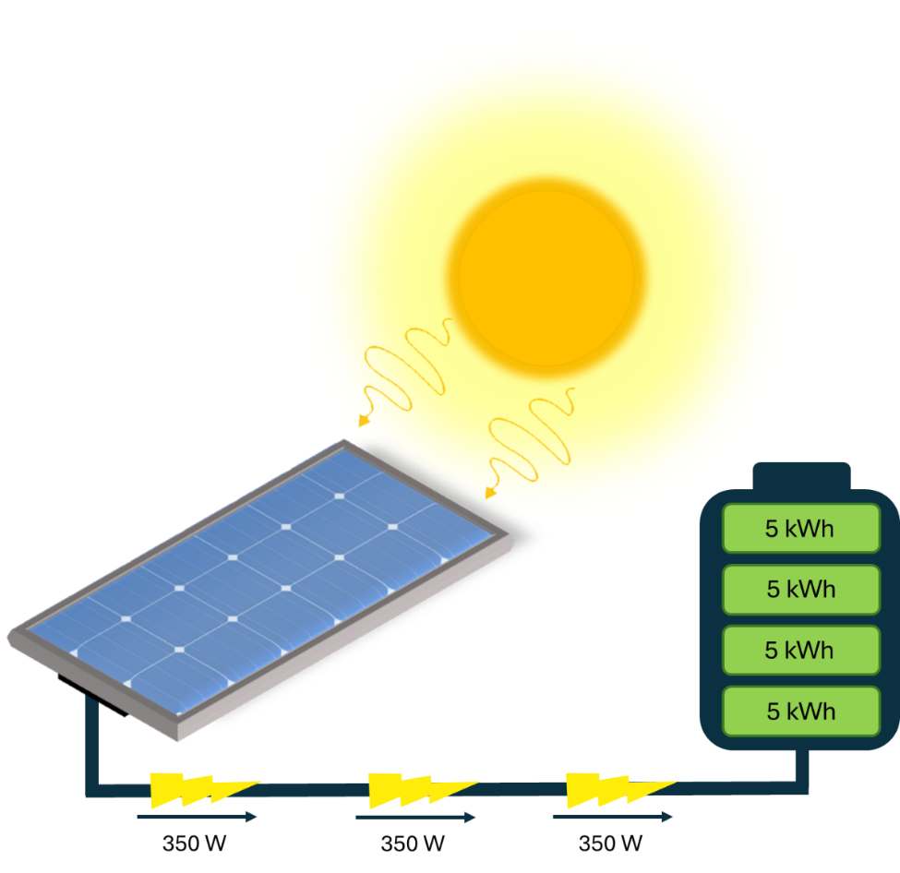

350 W

How do Energy and Power relate to generation and storage.

1. **Where to put panels on a roof?**

The orientation of a roof is important for collecting as much energy as possible from the sun.

1. What direction does the sun rise? Circle. North, South, East or West
2. What direction does the sun set? Circle. North, South, East or West
3. In summer, the sun moves high over the sky while in winter it is low in the sky. Based off the image, which direction does the sun travel lower in the sky in winter?

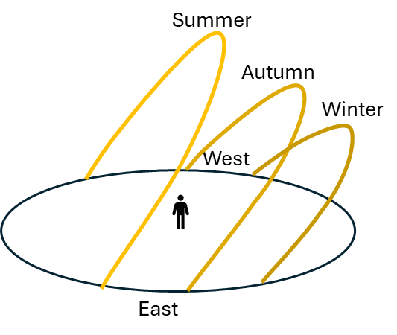

Circle. North, South, East or West

The amount of available sunny roof area can often be a limiting factor when deciding what system size to install, particularly for household solar systems in urban areas. Solar panels can be installed on roof areas that face north, east, west or, in some cases, south.

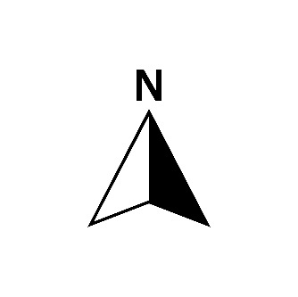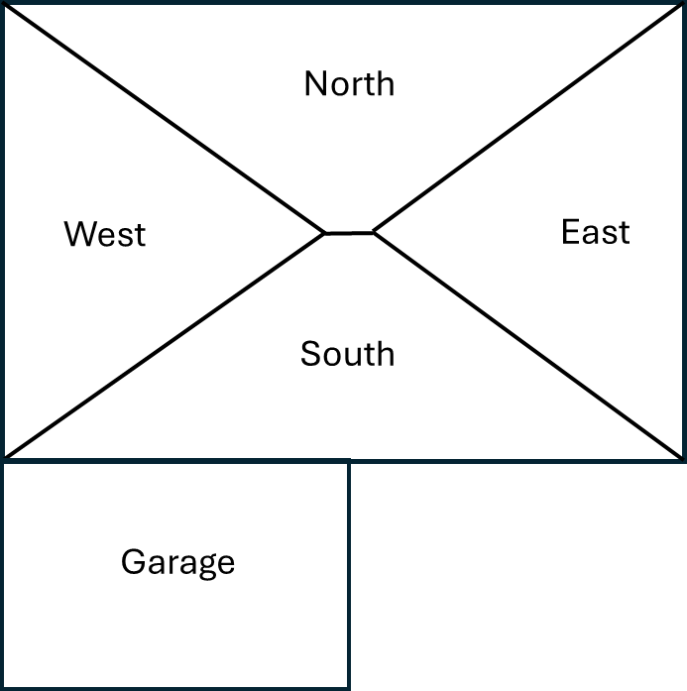

Above is a simple diagram of a house. Most of the time panels on north-facing roofs usually receive the most sunlight over the entire day and so generate the most electricity. Panels facing east will generate earlier in the morning while those facing west generate later in the afternoon.

1. In the solar electricity output diagram below for summer which data represents panels on a roof facing

NORTH _______ EAST _______

WEST _______ SOUTH _______

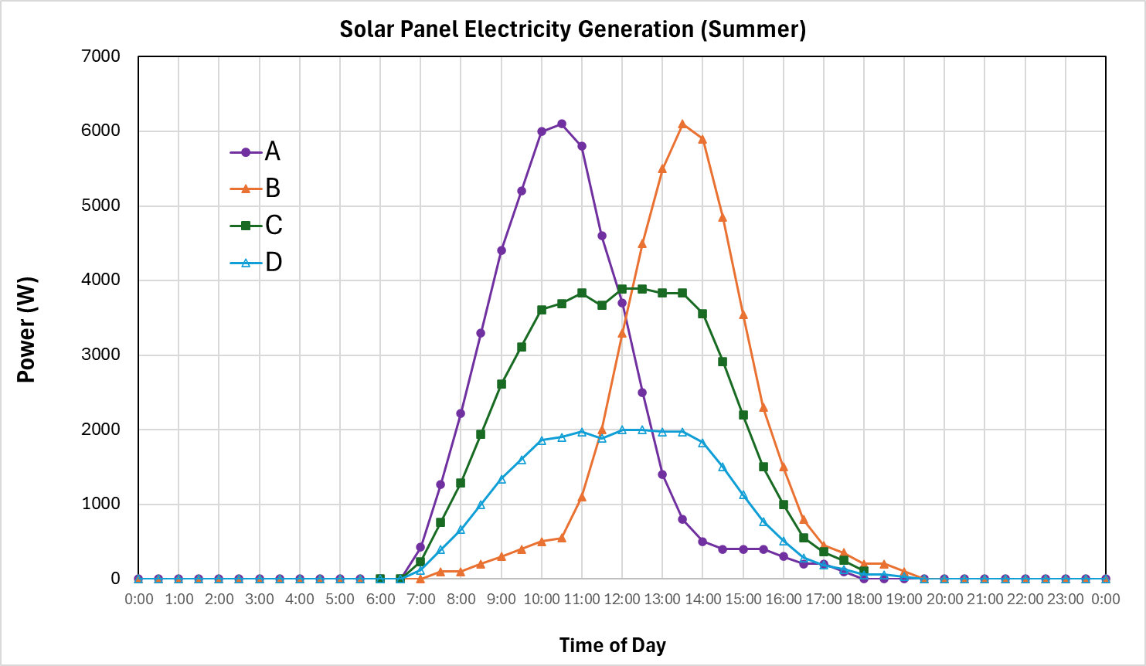

1. In the southern hemisphere the sun moves along the sky much lower to the north than in summer. This changes how much electricity can be generated and has dramatic effects of panels facing different directions. In the solar electricity output diagram below for winter which data represents panels on a roof facing

NORTH _______ EAST _______

WEST _______ SOUTH _______

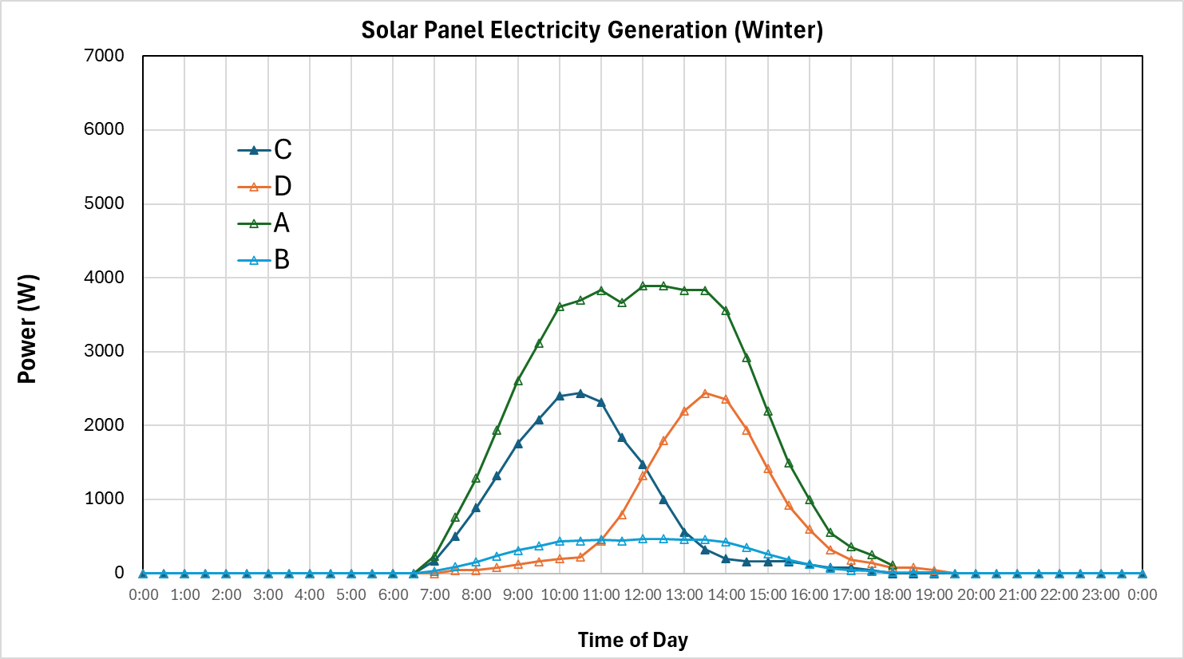

1. One residential solar panel is often around 1.7 m2 in area. A common 6 kW system take approximately 30 m2 of roof space, depending upon how good the panels are. Panels can be installed in portrait or landscape orientation to make the best use of the available roof space.
2. How many panels can you have for a typical 6 kW system mentioned above?

Hint:

Number of solar panels:______________ (rounded up or down to an integer)

**You can’t have parts of a panel!**

1. Based on the roof configuration below, where would you place the panels. All on one side, or split up across multiple directions? Discuss.

