## A Net Zero Education Collaboration to Inspire Our Future

## Digital Credential – Parent/Carer Permission Request

*Net Z(ed) is an initiative by MCB Business Partners (MCB), a leading Australian education outreach development agency and technology company, developed in collaboration with industry, education, and government agencies in the Hunter Region of NSW.*

**We request permission from parents and carers to issue an industry-recognised Digital Credential to students who complete Central Coast Education Network's curated classroom learning experiences and business engagement programs.**

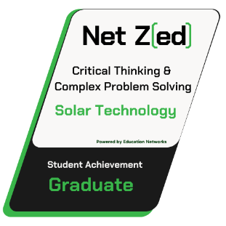The Ne Z(ed) Digital Credentials represent a modern and dynamic approach to recognising and validating students' skills and achievements while also gaining valuable, reflective insights from students relating to their experiences during the delivery of classroom programs*. The student's insights are being collected to inform the development and investment in further education programs by industry and government, supporting teachers in delivering learning experiences that will help prepare our young people for their future careers*.

This Permission Form informs you, as the parent or carer, about the Net Z(ed) Digital Credentials and requests permission for your child to apply for them, which includes providing their name and email address, upon successfully completing a Net Z(ed) learning experience.

Please be assured that students whose parents or carers choose not to provide permission for the issuance of Net Z(ed) Digital Credential will not be disadvantaged. Instead, they will receive a hard copy certificate acknowledging their participation in the learning experience or business engagement program.

If you have any questions or require further clarification, please visit the Net Z(ed) website – <https://netzed.com.au> or [contact us](https://netzed.com.au/contact-us/) directly.

## Parent / Carer Consent – Net Z(ed) Digital Credential

**Online Version:** [**https://netzed.com.au/credentials-digital-badges/parent-carer-information**](https://netzed.com.au/credentials-digital-badges/parent-carer-information)

* I give permission for my child to receive Net Z(ed) Credential and Digital Badges.
* I understand that my child will be required to provide Net Z(ed) with their name and email address so that the Digital Badge can be issued to them.
* I acknowledge that my child's information will be handled in accordance with Net Z(ed) [Privacy Policy](https://netzed.com.au/privacy-policy/).
* I understand that my child's information will only be used to award the Net Z(ed) Credential & Digital Badge and will not be shared with anyone else without my and my child's consent.
* I understand that participation in the Net Z(ed) Credentialling and Digital Badging is voluntary, and we may withdraw at any time.

|  |  |
| --- | --- |
| Student Name: |  |
| Student School: |  |
|  | |
| If under the age of 18 – Please have a parent/carer/guardian authorise: | |
| Name: |  |
| Signature: |  |
|  |  |
| Email address:  Optional |  |

Please return the Student Permission Form – to your school coordinator or send to: admin@netzed.com.au