Net Z(ed): Critical Thinking & Complex Problem Solving in Solar

Designing Photovoltaic Systems | Student Workbook Stage 5

Complete while watching the Centre for Organic Electronics video

1. **Introduction to Photovoltaic Systems**

Energy is often poorly understood by the General Public. Scientifically, how is energy defined:

Three units of energy are Joules, Calories and kiloWatthours? Go onto the internet and answer the following questions

1. How are each of these units defined
2. What are the conversion factors between these units?
3. Why are there different units for Energy? (Discuss in class)

i)

ii)

iii)

What is the Standard International (SI) Unit for Energy? _____________________________

Three units of power are Watts, Horsepower, ton of refrigeration. Go onto the internet and answer the following questions

1. How are each of these units defined
2. What are the conversion factors between these units?

i)

ii)

What is the Standard International (SI) Unit for Power? _____________________________

What is the unit for the Power used in your house? ______________________________

Based on these definitions of Power, write down an equation relating Energy and Power?

There are a number of scientific words that use “photo” in it, such as photosynthesis and photoluminescence. What does the word “photo’ mean in these contexts?

What does the word “voltaic” mean

Create a definition in your own words for ‘photovoltaic’:

Discuss the following diagram of a simplified photovoltaic system. Identify on the diagram the units of energy and power.

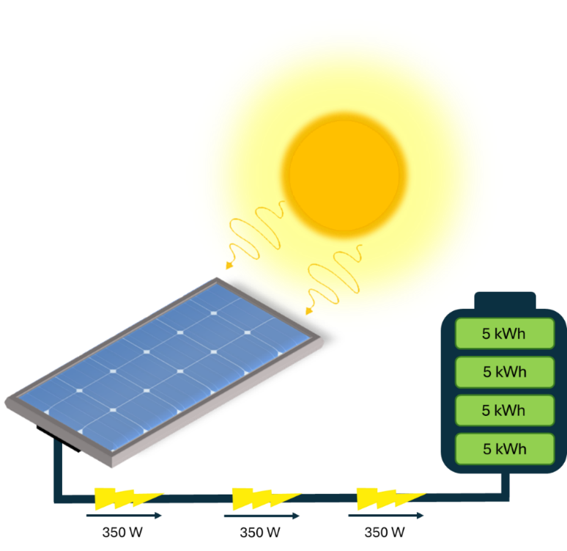

350W

How do Energy and Power relate to generation and storage.

1. **Energy and Power Analysis**
2. If a solar panel has a power capacity of 350 W. Calculate (in Wh) the total amount of energy that panel can produce in one day, given there are 5 hours of sunlight in a day.

Hint:

Daily energy output:_____________ Units _________

1. Convert the daily energy output from Wh to kWh.

Hint:

Daily energy output:___________ Units _________

1. Now that you have calculated how much energy is produced by one panel per day, calculate the number of panels required to meet a household energy demand of 25 kWh per day.

Hint:

Number of solar panels:________________ (rounded up or down to an integer)

**You can’t have parts of a panel!**

1. **Photovoltaic System Design Considerations**
2. Based on the number of panels you calculated, estimate the average cost of the 350W capacity photovoltaic system, given that the price of photovoltaic systems is approximately $2 per W.

Hint:

Average cost:_____________ Units _________

1. We want to now estimate the area required by the solar panels. This takes a couple of steps. Firstly, calculate the total power capacity of the photovoltaic system.

System power capacity:______________ Units _________

Now calculate the required amount of power from sunlight. This requires the use of the panel efficiency which is 20 %. In other words, for every 100 W of sunlight the panel absorbs, only 20 W of electricity is produced. This can be written mathematically as:

Hint:

Sunlight power required:______________ Units _________

Finally, calculate the area required by the solar panels based on the solar irradiance (power from the sun) of 1000 W per m2 (this means that the solar power in one square meter is 1000 W).

Hint:

Area required:________________ Units _________

Testing your knowledge! Turn Over for Case Study

1. **Case Study**

The Atkinson family have an average daily energy consumption of 35 kWh per day. The family recently decided to install a photovoltaic system. They recently received a quote from Super Solar Corp. and are unsure if the proposed system fits their needs and is at a reasonable cost. Analyse the quote and determine if the quote is suitable for the family and justify whether the family should or should not purse the quote further, justify why or why not. If the proposed system is unreasonable, what would a more suitable system look like?

Consider:

* does the number of panels meet the demand assuming 5 hours of sunlight per day;
* is the total system cost reasonable (e.g. between $1 - $3 per Watt)?

