Net Z(ed): Critical Thinking & Complex Problem Solving in Solar

Designing Photovoltaic Systems | Stage 5 Teacher Guide

**Background**

The world is shifting away from fossil fueled energy to combat climate change. As a result, renewable energy has experienced mass deployment in a wide range of areas. Solar energy in the form of solar panels has found use in small scales such as outside lighting and camping, medium scales such as powering households and commercial buildings to large scale deployment in the form of solar farms. This lesson aims to teach students about the design considerations for implementing solar energy on different scales, the use of solar energy and storage considerations, as well as understanding the role of units in calculations.

**Learning Aims and Outcomes**

* Understand the basic components of a photovoltaic system
* Understanding the difference between energy and power
* Calculate and design the number of solar panels required to meet an energy demand
* Consider impacts of solar energy (e.g. cost and area required for solar panels)

**Accompanying material**

There is a stage 5 video that should be run in sink with the worksheet. There are prompts in the video to pause it when the students should attempt certain questions. Please have a run through of the video first while looking at the work sheet before using in class. This will help with timing.

**Gamification**

Instructors are encouraged to award points to students who get questions correct or are first to get the correct information off the internet.

**Lesson Plan**

1. **Introduction to Photovoltaic Systems**

* Objective: Define key terms and introduce the basic of solar generated energy
* Teaching points:
  + Components solar panels, battery, power, energy
  + Key concepts:
    - Solar panels convert sunlight into electricity
    - Energy; the ability to do work, cause change, move objects, run electronic devices. This can be in terms of movement, heat, chemical energy (e.g. in batteries) and is generally expressed in terms of watt hours (Wh) or kilowatt hours or kWh where 1,000 Wh is equal to 1 kWh.
    - Power; is the rate at which energy is used, produced or delivered. This is the measurement of energy and how it changes with time and is generally expressed in terms of watts (W) or kilowatts (kW) where 1,000 W is equal to 1 kW.
    - Photovoltaics; photo meaning light, voltaic meaning electricity. Photovoltaics relates to the production of electricity through the exposure of light. Using photovoltaics allows for the generation of renewable electricity from sunlight.
    - Power and energy; a solar panel generates power when exposed to sunlight. Over the course of the day the panel will generate a total amount of energy that can be used or stored in a battery. This can be thought of like filling a bucket with water; e.g. the tap is the solar panel, water is electricity and the bucket is a batter. When the tap is turned on (sunlight on the solar panel), water will flow out of the tap at a rate, i.e. so many liters exit the tap per minute (this flowrate of water is like the power produced by a solar panel), the water fills up the bucket with an amount of liters (the amount of water in the bucket is representative of the amount of energy in the bucket. When we look at how power and energy relate to each other, if a solar panel has a power rating of 350 W then the amount of energy produced in an hour by the panel is 350 Wh, after two hours it would have produced 700 Wh, after three hours the amount of energy produced is 1,050 Wh. If a batter has 20 kWh of stored energy, then it can deliver 20 kW (or 20,000 W) in an hour, or 10 kW (10,000 W) in 2 hours.
  + Activities:
    - Discuss and define the terms ‘energy’

Three units of energy are Joules, Calories and kiloWatthours? Go onto the internet and answer the following questions

* + - * How are each of these units defined

**Joules** - The work done by a force of one newton acting through one metre.

**Calories** - a unit of energy equivalent to the heat energy needed to raise the temperature of 1 gram of water by 1 °C (now often defined as equal to 4.1868 joules.

**kiloWatthours** - 1 KWh is the amount of energy consumed when an electric appliance having a power rating of 1 Kilowatt is used for 1 hour. 1Joule = 2.8x10-7 kWh.

Why are there different units for Energy? (Discuss in class)

To make working with the numbers in the calculations easier

* + - Discuss ‘power’

Three units of power are Watts, Horsepower, ton of refrigeration. How are each of these units defined

Watts - equivalent to one joule per second.

Horsepower - Horsepower refers to **the power an engine produces**. It's calculated through the power needed to move 550 pounds one foot in one second. 1 Horsepower = 745.7 Watt

Ton of refrigeration - used to describe how much heat a refrigeration or air conditioning system can remove per unit of time. 1 ton of refrigeration = 3.517 kilowatts (kW).

* + - Discuss the units for energy (W, kW) and power (Wh and kWh).
    - Define ‘photo’ and ‘voltaic’, lead this discussion to define the word ‘photovoltaic’
    - Discuss the diagram of a simplified photovoltaic system. Identify the units of energy and power, and how they relate to generation and storage.

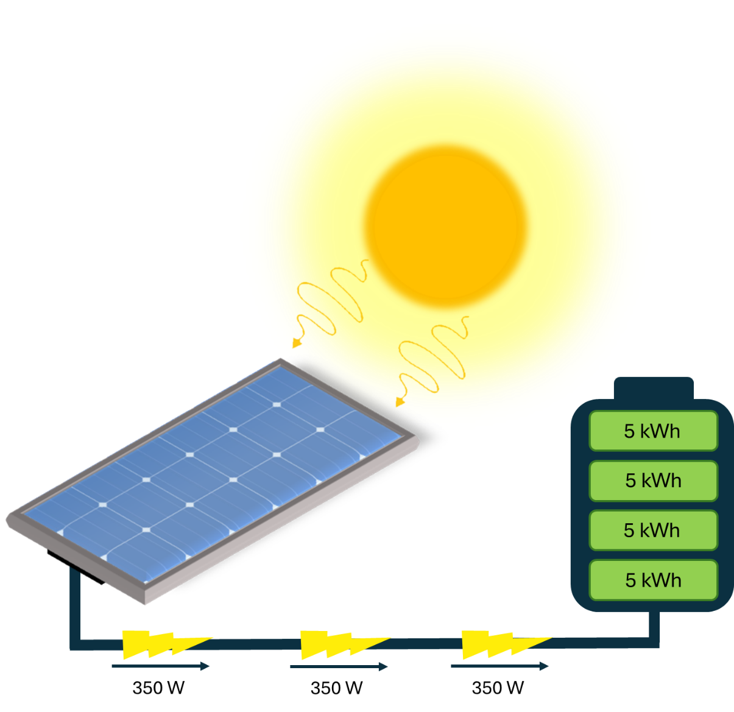

350W

1. **Energy and Power Analysis**
2. Daily energy output per panel

This means that one solar panel will produce 1 750 Wh of energy per day.

1. Convert from Wh to kWh

This conversion can be rewritten as

Therefore we can convert Wh to kWh

1. Number of solar panels

Here it might be important to note the use of ‘panel’ in the energy output per panel. While it wasn’t used explicitly in the units previously it was used implicitly when it was said “1.74 kWh/day per panel.”

Also note here while these numbers can be divided, it is easy to ‘flip’ the bottom number and then multiply the two. This will better show how the units cancel out.

This number has to be rounded to a whole number. Either rounding down to 14 panels or 15 panels is acceptable, so long as the students acknowledge that “0.28…” of a panel is not realistically practical. Video rounds up but students don’t need to.

1. **Photovoltaic System Design Considerations**
2. Cost estimation

For 14 panels:

Minimum cost of $2/W

For 15 panels:

Minimum cost of $2/W

1. Area estimate

Start with the system power capacity:

For 14 panels:

For 15 panels:

Next calculate the sunlight required:

Here it is important to highlight the labelling of Watts. While they are both measures of power, they are not the same. The labelling is a way of distinguishing between the power from sunlight and the electrical power generated.

For 14 panels with a capacity of 4.9 kW:

For 15 panels with a capacity of 5.25 kW:

The area required is then

For 14 panels with a capacity of 4.9 kW:

For 15 panels with a capacity of 5.25 kW:

1. **Case Study**

This task can be undertaken in various ways. This task is to assess how well students have understood the previous tasks, application of these skills and critical analysis of information.The proposed quote is not suitable for the family as the number of modules is insufficient to generate the required energy demand, as well as being overpriced. This can be checked by:

How much energy is generated by the 15 panels per day:

Therefore, the system only produces 22.5 kWh of energy per day. This is short of the household energy demand of 35 kWh by 12.5 kWh.

Assess the cost of the system:

The estimated costs for residential photovoltaic systems vary between $1 per watt and $3 per watt. Check and see if the cost of the quoted system is within this range.

Therefore, the cost of this system is $7.83 per watt. Much higher than the maximum limit of $3 per Watt.

As a result, this system is not reasonable as it does not meet the energy demand and is overpriced. Students should justify this decision with these calculations.

What would a more reasonable system look like:

* Number of panels

Therefore, a more reasonable number of the specific panels mentioned in the quote would be either 23 to 24 panels.

* Approximate cost

For 23 panels

Minimum

Maximum

For 24 panels

Minimum

Maximum

Therefore, a more reasonable system cost would be between $6 900 and $20 700 for 23 panels, or $7 200 and $21 600 for 24 panels.

A suggestion made by students might be negotiation with Super Solar Corp. or seek a second quote that fits closer to 23- 24 panels between $6 900 and $21 600.