Net Z(ed): Critical Thinking & Complex Problem Solving in Solar

Designing Photovoltaic Systems | Stage 4 Teacher Guide

**Background**

The world is shifting away from fossil fueled energy to combat climate change. As a result, renewable energy has experienced mass deployment in a wide range of areas. Solar energy in the form of solar panels has found use in small scales such as outside lighting and camping, medium scales such as powering households and commercial buildings to large scale deployment in the form of solar farms. This lesson aims to teach students about the design considerations for implementing solar energy on different scales, the use of solar energy and storage considerations, as well as understanding the role of units in calculations.

**Learning Aims and Outcomes**

* Understand the basic components of a photovoltaic system
* Understanding the difference between energy and power
* Calculate and design the number of solar panels required to meet an energy demand
* Consider impacts of solar energy (e.g. cost and area required for solar panels)

**Accompanying material**

There is a stage 4 video that should be run in sync with the worksheet. There are prompts in the video to pause it when the students should attempt certain questions. Please have a run-through of the video first while looking at the worksheet before using it in class. This will help with timing.

**Gamification**

Instructors are encouraged to award points to students who get questions correct or are the first to get the correct information from the internet.

**Lesson Plan**

1. **Introduction to Photovoltaic Systems**

* Objective: Define key terms and introduce the basics of solar generated energy
* Teaching points:
  + Components: solar panels, battery, power, energy
  + Key concepts:
    - Solar panels convert sunlight into electricity
    - Energy; the ability to do work, cause change, move objects, run electronic devices. This can be in terms of movement, heat, chemical energy (e.g. in batteries) and is generally expressed in terms of watt hours (Wh) or kilowatt hours or kWh where 1,000 Wh is equal to 1 kWh.
    - Power; is the rate at which energy is used, produced or delivered. This is the measurement of energy and how it changes with time and is generally expressed in terms of watts (W) or kilowatts (kW) where 1,000 W is equal to 1 kW.
    - Photovoltaics; photo meaning light, voltaic meaning electricity. Photovoltaics relates to the production of electricity through the exposure of light. Using photovoltaics allows for the generation of renewable electricity from sunlight.
    - Power and energy; a solar panel generates power when exposed to sunlight. Over the course of the day the panel will generate a total amount of energy that can be used or stored in a battery. This can be thought of like filling a bucket with water; e.g. the tap is the solar panel, water is electricity and the bucket is a battery. When the tap is turned on (sunlight on the solar panel), water will flow out of the tap at a rate, i.e. so many liters exit the tap per minute (this flowrate of water is like the power produced by a solar panel), the water fills up the bucket with an amount of liters (the amount of water in the bucket is representative of the amount of energy in the bucket. When we look at how power and energy relate to each other, if a solar panel has a power rating of 350 W then the amount of energy produced in an hour by the panel is 350 Wh, after two hours it would have produced 700 Wh, after three hours the amount of energy produced is 1,050 Wh. If a batter has 20 kWh of stored energy, then it can deliver 20 kW (or 20,000 W) in an hour, or 10 kW (10,000 W) in 2 hours.
  + Activities:
    - Discuss and define the terms ‘energy’ and ‘power’
    - Discuss the units for energy (W, kW) and power (Wh and kWh).
    - Define ‘photo’ and ‘voltaic’, lead this discussion to define the word ‘photovoltaic’
    - Discuss the diagram of a simplified photovoltaic system. Identify the units of energy and power, and how they relate to generation and storage.

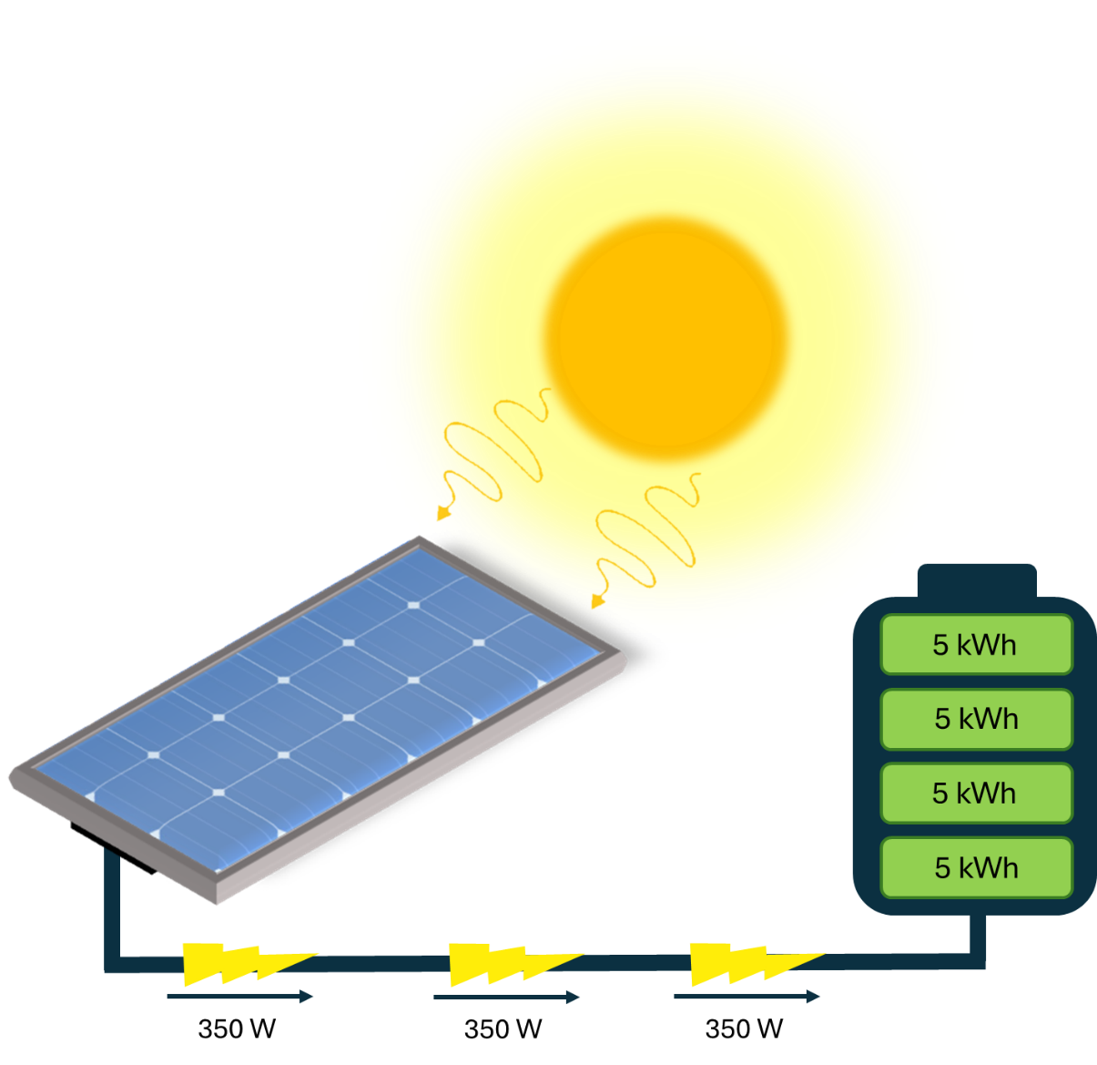

350W

1. **Where to put panels on a roof?**

The orientation of a roof is important for collecting as much energy as possible from the sun.

1. What direction does the sun rise? Circle. North, South, East or West
2. What direction does the sun set? Circle. North, South, East or West
3. In summer, the sun moves high over the sky while in winter it is low in the sky. Based off the image, which direction does the sun travel lower in the sky in winter?

Circle. North, South, East or West

The amount of available sunny roof area can often be a limiting factor when deciding what system size to install, particularly for household solar systems in urban areas. Solar panels can be installed on roof areas that face north, east, west or, in some cases, south.

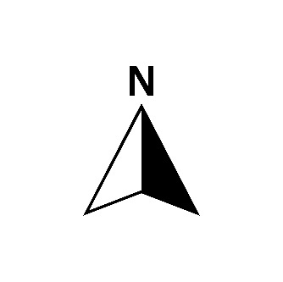

Above is a simple diagram of a house. Most of the time panels on north-facing roofs usually receive the most sunlight over the entire day and so generate the most electricity. Panels facing east will generate earlier in the morning while those facing west generate later in the afternoon.

1. In the solar electricity output diagram below for summer which data represents panels on a roof facing

C

A

NORTH _______ EAST _______

D

B

WEST _______ SOUTH _______

1. In the southern hemisphere the sun moves along the sky much lower to the north than in summer. This changes how much electricity can be generated and has dramatic effects of panels facing different directions. In the solar electricity output diagram below for winter which data represents panels on a roof facing

A

D

C

NORTH _______ EAST _______

B

WEST _______ SOUTH _______

1. One residential solar panel is often around 1.7 m2 in area. A common 6 kW system take approximately 30 m2 of roof space, depending upon how good the panels are. Panels can be installed in portrait or landscape orientation to make the best use of the available roof space.
2. How many panels can you have for a typical 6 kW system mentioned above?

Hint:

= 30 / 1.7 = 17.6

Number of solar panels:______17 or 18___ (rounded up or down to an integer)

**You can’t have parts of a panel!**

1. Based on the roof configuration below, where would you place the panels. All on one side, or split up across multiple directions? Discuss.

There is no real wrong answer here. Best would probably be split up on three sides, East West and North. But could have all on North, or just East and West.